WEB SERVICES

What is **Web Services**?

Method of communication between two devices over a network

It is a collection of standards or protocols for exchanging information between two devices or application.

[A **protocol** is a particular set of rules for having a conversation between two computers to convey a specific set of information.

A **standard** (and in the networking arena, many **protocols** are **standards**) is a document that specifies something that has the overwhelming support and agreement of the **standards** making body]

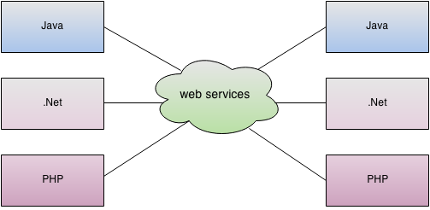

As you can see in the figure, java, .net or PHP applications can communicate with other applications through web service over the network. For example, java application can interact with Java, .Net and PHP applications. So web service is a language independent way of communication.

TYPES OF Web Services

1. SOAP
2. RESTful

Web Services Components

1. SOAP
2. WSDL
3. UDDI

**SOAP** - ***Simple Object Access Protocol***

SOAP is a **XML-based protocol** for **accessing web services.**

SOAP is a W3C recommendation for communication between applications.

SOAP is XML based, so it is platform independent and language independent. In other words, it can be used with Java, .Net or PHP language on any platform.

By using SOAP, you will be able to interact with other programming language applications.

One of the Advantage is it defines its own security called **WS Security**

**WSDL*- Web Service Descriptive Language*.**

It is a **Xml Document** which **contains method name, method parameter and how to access it.**

WSDL acts as a **interface** **between** **web applications.**

## UDDI- *Universal Descriptive Discovery and Integration*

UDDI is a **XML based framework** for describing, discovering and integrating web services.

UDDI is a **directory of web service** interfaces described by WSDL, containing information about web services.

**RESTful Web Services**

Representational State Transfer.

It’s an Architectural Style and not a protocol.

## Advantages of RESTful Web Services

**Fast**: RESTful Web Services are fast because there is no strict specification like SOAP. It consumes less bandwidth and resource.

**Language and Platform independent**: RESTful web services can be written in any programming language and executed in any platform.

**Can use SOAP**: RESTful web services can use SOAP web services as the implementation.

**Permits different data format**: RESTful web service permits different data format such as Plain Text, HTML, XML and JSON.

The Difference Between XML and HTML

XML and HTML were designed with different goals:

* XML was designed to carry data - with focus on what data is
* HTML was designed to display data - with focus on how data looks
* XML tags are not predefined like HTML tags are

**XML Simplifies Things**

* It simplifies data sharing
* It simplifies data transport
* It simplifies **platform changes**
* It simplifies data availability